CodeNEXT will make many homes in older neighborhoods nonconforming

CodeNEXT defines for R2C (SF zoning for most of central Austin)

- Structure placement
- Structure height
- Top plate (i.e. bottom of roof line) height
- Pool placement
- Carport placement
- Lot sizes and widths

For example, CodeNEXT establishes maximum setbacks:
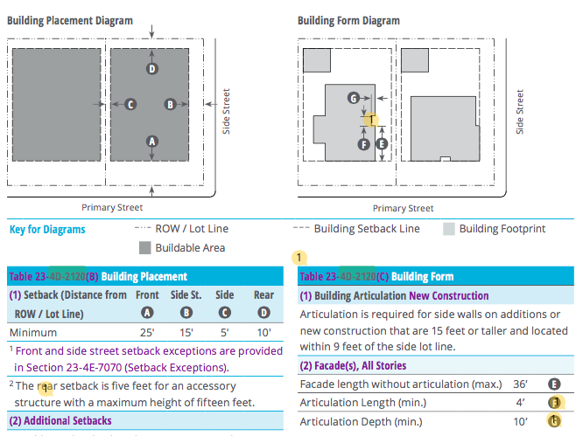

If your house is zoned R2C and is

- Within 5’ of neighbor’s property line
- Within 15’ of a side street
- Within 25’ of front property line
- Within 10’ of the back property line
- If your house has a carport, it cannot be closer to the street than the front of the house
- Has a top plate that higher than 22’
- Is taller than 32’
- The lot is less than 5,000 sq. ft.
- If you have a pool that is In front of the house, less than 13’ from a side street, 3’ from the side property line or less than 8’ from the back property line

It will be nonconforming under CodeNEXT

Current code explicitly grandfathers non-complying structures from the previous code:
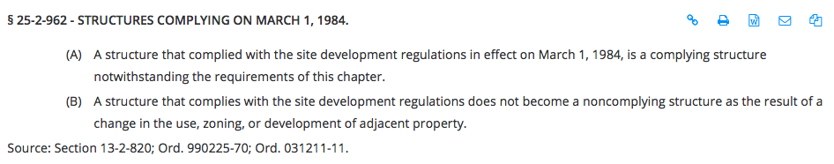

CodeNEXT explicitly does not grandfather; instead, it seeks to “phase-out” & limit investments in them:
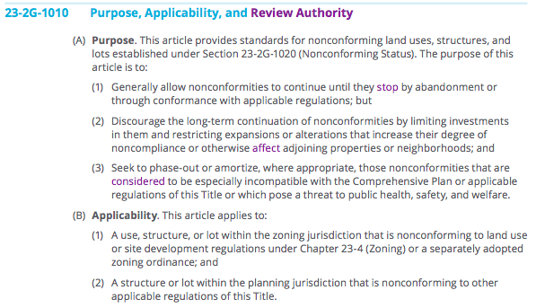

If your house is nonconforming you will need to apply for a Certificate of Occupancy and include “supporting documentation.” Below are excerpts from the section outlining the process:
